Construction of a Sagnac Interferometer for precise measurements of angular velocity

Arnav Ranjekar, Manoj Kumar

Introduction:

A Sagnac interferometer consists of highly reflecting mirrors arranged in a circle. A beam of light is split and the two beams are made to follow the same path but in opposite directions. On return to the point of entry the two light beams are allowed to exit the ring and undergo [interference](https://en.wikipedia.org/wiki/Interference_(wave_propagation)). The relative phases of the two exiting beams, and thus the position of the interference fringes, are shifted according to the [angular velocity](https://en.wikipedia.org/wiki/Angular_velocity) of the apparatus. In other words, when the interferometer is at rest with respect to a [nonrotating frame](https://en.wikipedia.org/wiki/Inertial_frame_of_reference), the light takes the same amount of time to traverse the ring in either direction. However, when the interferometer system is spun, one beam of light has a longer path to travel than the other in order to complete one circuit of the mechanical frame, and so takes longer, resulting in a phase difference between the two beams.

The amount of displacement is proportional to the angular velocity of the rotating platform. The axis of rotation does not have to be inside the enclosed area. The phase shift of the interference fringes is proportional to the platform's [angular frequency](https://en.wikipedia.org/wiki/Angular_frequency) and is given by a formula originally derived by Sagnac.



The difference in travel times, when multiplied by the optical frequency , determines the phase difference .

The time taken for the laser to complete one round around the loop will be Circumference + distance moved my earth/c . And that L = rwt, so we get relation for time. Same for beam travelling in opposite direction, with rw term subtracted. That gives delta t expression.

Other applications include GNSS & GPS navigation systems. As the project progresses, new research avenues could be discussed.

Equipment used: Optical board, 2 extension boards for mounting laser & the screen, polarizers, lens, 3 high reflectivity mirrors, beam splitter, green laser 532.8nm, Screen, Fringe marker chart, aligning cross plate, required holders.

Setup:

We start by attaching the extensions to opposite corners of the optical board. On one end place the laser light, then on the corner of the board, place the beam splitter. Align the beam vertically using the cross plate & thereby place the first mirror on the next corner. Adjust its angle and height such that the laser beam travels a straight path to the next corner. Repeat the process for the other mirrors, and similarly adjust the beam travelling in the opposite direction. Now place 2 polarizers at 0˚ angle between the laser beam & beam splitter path to avoid light from getting back into the laser.

Now we have 2 beams travelling in opposite directions in the setup, they should form a bright spot on the screen. We placed a lens of f=20cm in order to magnify the fringes observed. This entire assembly was placed on a rotating platform disc. Given below is a photograph of the setup.

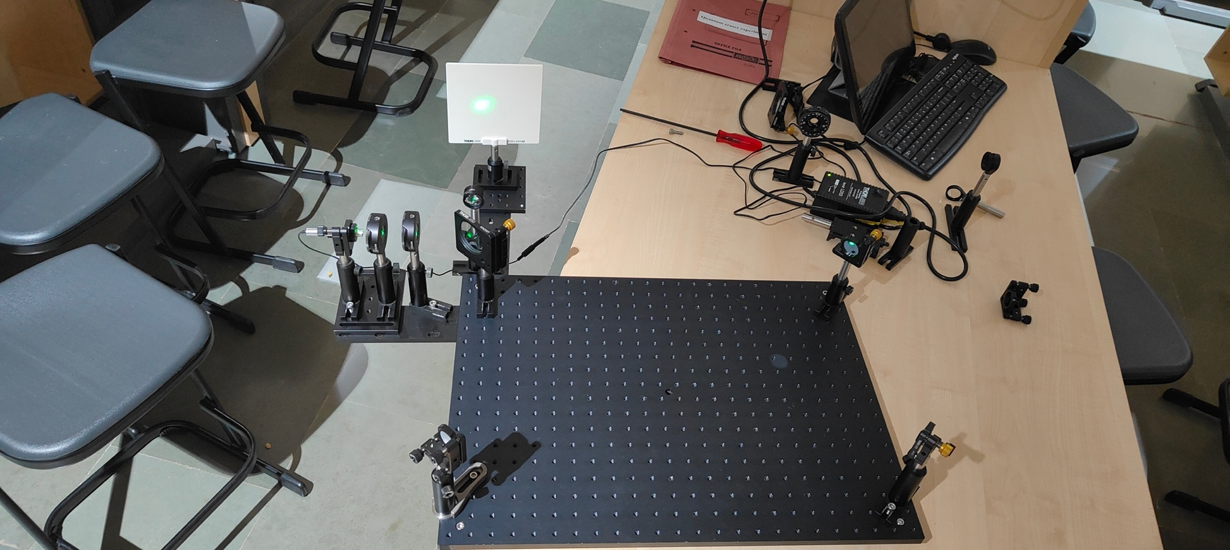 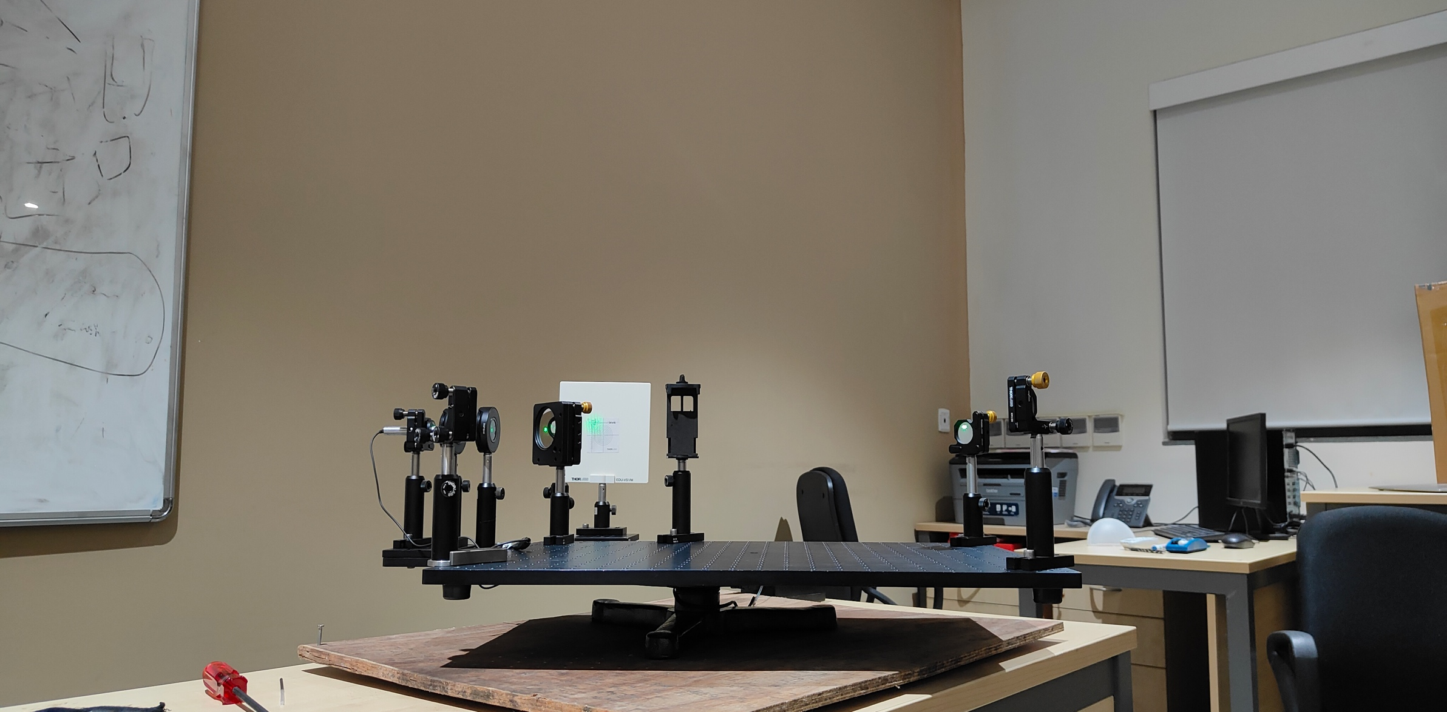

Fig1. Top view Fig2. After placing on a rotating platform

Observations:

The entire setup was rotated at a constant velocity by manually giving a push. A phone camera was attached to a holder & slow motion video was recorded at settings of 720p resolution & 240fps. We tried variations by increasing & decreasing fringe size and making markings with a marker/pen. Later on, a chart with markings was also used to try & measure the fringe shift; multiple videos with different indoor lighting settings were recorded. I filtered the best videos; it was observed that the shift wasn’t detectable to the naked eye. So analysis using software had to be performed.

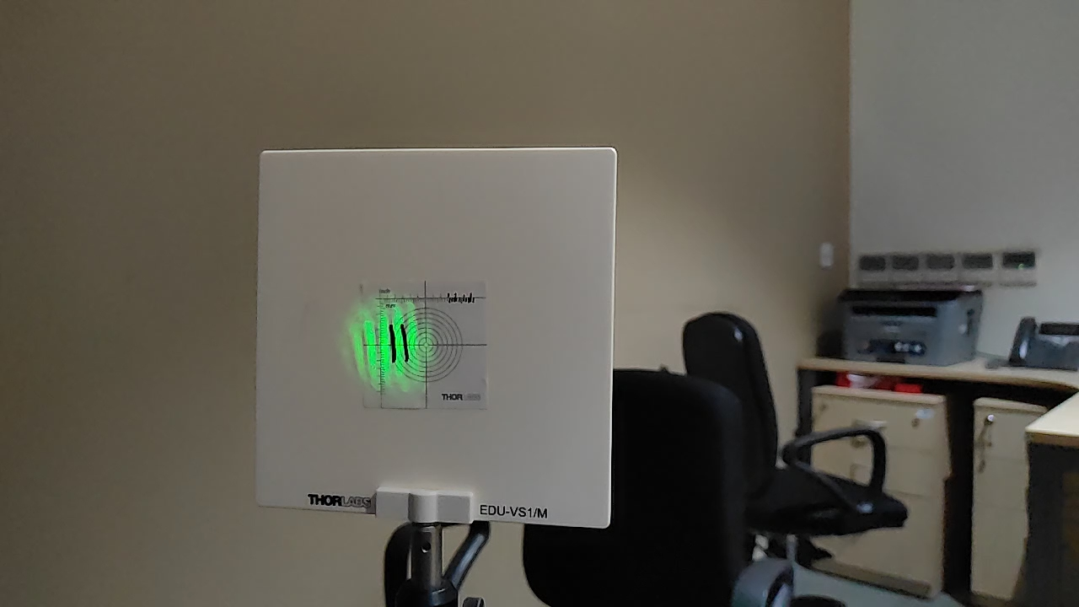

Fig3. Big fringe with marking & chart

Analysis & Results:

I used MATLAB software to analyze the results. The idea was to select a small Region of Interest (ROI) and then see the pixel shift with maximum intensity over time. I wrote code to select the ROI from the video & process the frames such that the shift in pixels along the X & Y axis was calculated & plotted on a graph. Below is the graph.

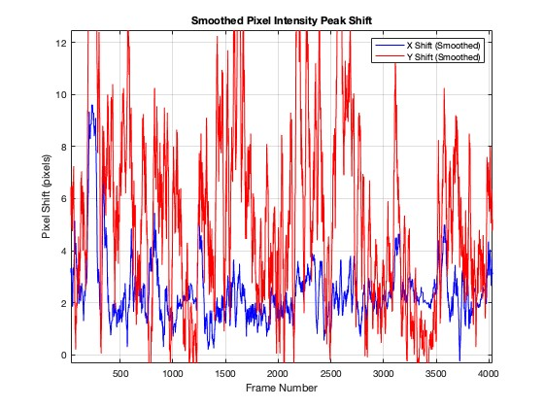

Fig 4. Smoothed by applying a gaussian filter to remove noise

Now, from the video I calculated the angular velocity which turned out to be around 2.1 rad/s. Now, using this in the formula ΔN = 4Aω/cλ, this gives us a ΔN = 0.016, which is a very small value. The area of the setup was calculated by taking a mean radius of 33.5cm, taking into account the board dimensions & also the extensions used. As seen from the above graph, detecting such a small shift is very difficult due to the present noise. A shift of 0.016 corresponds to about a 0.3-pixel shift, given that the diameter of the central fringe is 17 pixels.

Observed from the diagram is a continuous shift of around 0.5 pixels, but it is important to note that this reading is populated with a lot of noise, which cannot be eliminated analytically. Taking this as the minimum shift, the calculated angular velocity is 3.32 rad/s, which is higher than calculated from the video.

To get highly accurate results, one should perform the experiment in a dark room, use a photo-sensing detector & motorise the mechanism to provide torque to the setup. Also phase shift can be calculated instead of fringe shift.

Link to the MATLAB code: <https://github.com/Zubenalgenubi/Sagnac-Interferometer>

Recording of fringe pattern: <https://youtu.be/4rMq6puM3X8>

Arnav Ranjekar 2022A3PS0421G